Group 4, Milestone #4 Presentation
Team Members: Zak Nizam, Caleb Schumacher
Selected Case Study: Willson Financial Services

Case Study Summary:
Jake and Ned Wilson both attained degrees in finance with Ned also obtaining an MBA. They proceeded to open a financial management business called Wilson Financial. Their company has grown steadily over the last year of operations, so they are looking to refine their business process with a primary decision to make of whether to change their current billing process for certain customers. To figure out the best choice, the Wilson brothers have three main questions that need to be answered based on the data they have on hand:
- How many clients have been added for each of the past six months?
- What is the average amount of assets (in currency) for the entire client list?
- How many clients have a high number (more than 10 a month) of transactions?

These are the initial business rules we agreed upon based on the selected case study:
- A Client may have many Transactions.
- Each Transaction must belong to one and only one Client.
- Each Client has a total amount of Assets Under Management (AUM) recorded in the system.
- A Client is uniquely identified by a client_id.
- Each Transaction must include a transaction date and transaction amount.
- Each Transaction must be classified by a transaction type (e.g., deposit, withdrawal, transfer).
- The system must track the date a Client was added to the firm.
- The system must support reporting on the number of clients added per month.
- The system must support calculating the average assets across all clients.
- The system must support identifying clients with more than ten transactions within a single month.
- An Employee may schedule many Client Appointments.
- Each Appointment must be associated with one Client and one Employee.

The ERD below reflects the business rules defined above: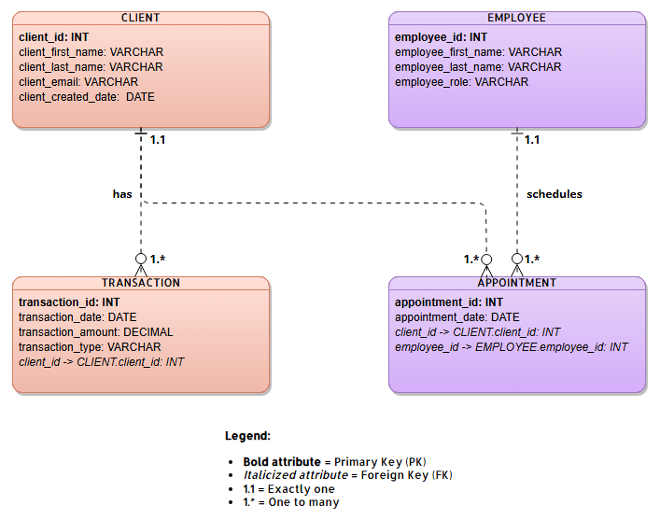

Report 1 – Clients Added in the Last Six Months
This report shows how many new clients were added to Willson Financial during each of the last six months. The purpose of this report is to evaluate growth trends and determine whether the client base is increasing consistently or fluctuating over time. By grouping clients by the month their account was created, the firm can identify whether marketing efforts and business strategies are effectively attracting new clients. This information helps leadership decide whether adjustments are needed to improve client acquisition.
Figure 1: Screenshot of terminal showing clients added within last 6 months
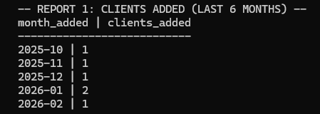

Report 2 – Average Total Assets Across All Clients
This report calculates the average total assets across the entire client base. Because total assets are derived from transaction history (deposits and withdrawals), the report dynamically calculates each client’s net balance and then determines the overall average. This allows the firm to understand the general financial profile of their clients. Knowing the average asset level can help guide decisions regarding service offerings, pricing models, and whether the firm should consider adjusting its billing structure.
Figure 2: Screenshot of terminal showing average total assets across all clients
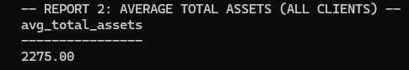

Report 3 – Clients with More Than 10 Transactions in a Single Month
This report identifies clients who had more than ten transactions within a single month. The purpose of this report is to highlight high-activity clients. A high number of transactions may indicate active trading behavior, which could impact workload, compliance monitoring, or billing considerations. By identifying these clients, the firm can evaluate whether their current fee structure appropriately reflects the level of service being provided.
Figure 3: Screenshot of terminal showing clients with 10+ transaction withins 1 month
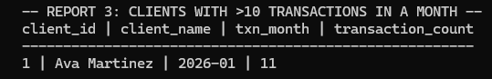

Because the case study does not explicitly define every detail, we made the following assumptions when putting together the ERD and the reports :
- “Client added” refers to the client_created_date field stored in the database.
- Assets are stored as a single aggregated currency value per client, rather than broken down into individual holdings.
- Transactions are stored individually and include transaction_date and transaction_amount.
- A month is determined using the transaction_date field.
- Each employee has a unique employee_id.
- Currency values will be stored using a DECIMAL data type.
- Dates will be stored using the DATE data type in YYYY-MM-DD format.

Conclusion:
Based on the current relevant data, the only client that would potentially need to have their billing structure revisited would be Ava Martinez. This is subject to change as business continues to grow as it has been according to report 1. If there is an increase in clients who average at least 10 transactions per month, their billing structure may also need to be revisited. For now, the business is still small but growing steadily, so any major changes to be made are not a high priority matter.

